CBUAE Cyber Compliance for Log360
Automate CBUAE Cyber compliance and fortify cybersecurity resilience for financial institutions.
Region: UAE | Type: Financial Services, Cybersecurity Framework, Incident Management, Operational Resilience | Category: Compliance | Pricing: Free

Overview
The CBUAE Cyber compliance extension in Log360 helps organizations meet the Central Bank of the UAE Cybersecurity Regulations and Information Security Standards, CBUAE's mandatory framework for cyber risk governance, security operations, and operational resilience in regulated financial institutions by providing centralized log management, threat detection, identity monitoring, and compliance reporting. The platform supports CBUAE Cyber requirements for risk governance, identity management, security operations, incident response, network security, endpoint protection, and operational resilience.
For Cyber Risk Governance and Policy Enforcement, Log360 aggregates policy modification and administrative change events to support governance accountability and regulatory review. To address Identity and Access Management, the platform monitors authentication events across Active Directory, cloud identity providers, and network devices. The extension also supports Security Operations and Continuous Monitoring by providing capabilities that consolidates security events from all log sources to enable real-time detection and correlation.

Key Features
- Incident Management and Response: Log360 provides real-time alerts and forensic log data to support incident response workflows.
- Network and Infrastructure Security: Log360 provides unified visibility into firewall policy changes, network logon events, and attack attempts.
- Endpoint Security and Removable Media Control: Log360 monitors endpoint threats, removable media events, and application execution across the enterprise.
- Operational Resilience and Business Continuity: Log360 tracks backup job completion, DR policy changes, and recovery event logs to support resilience assurance.
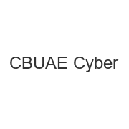
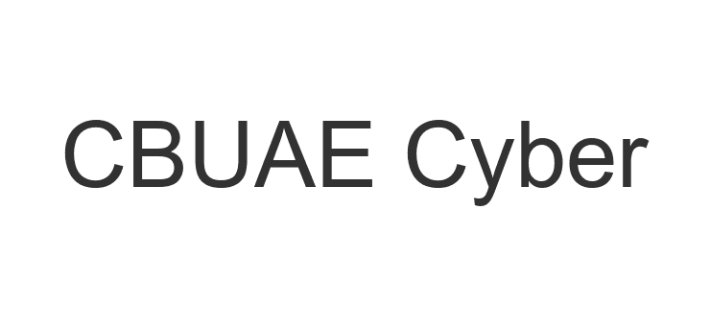
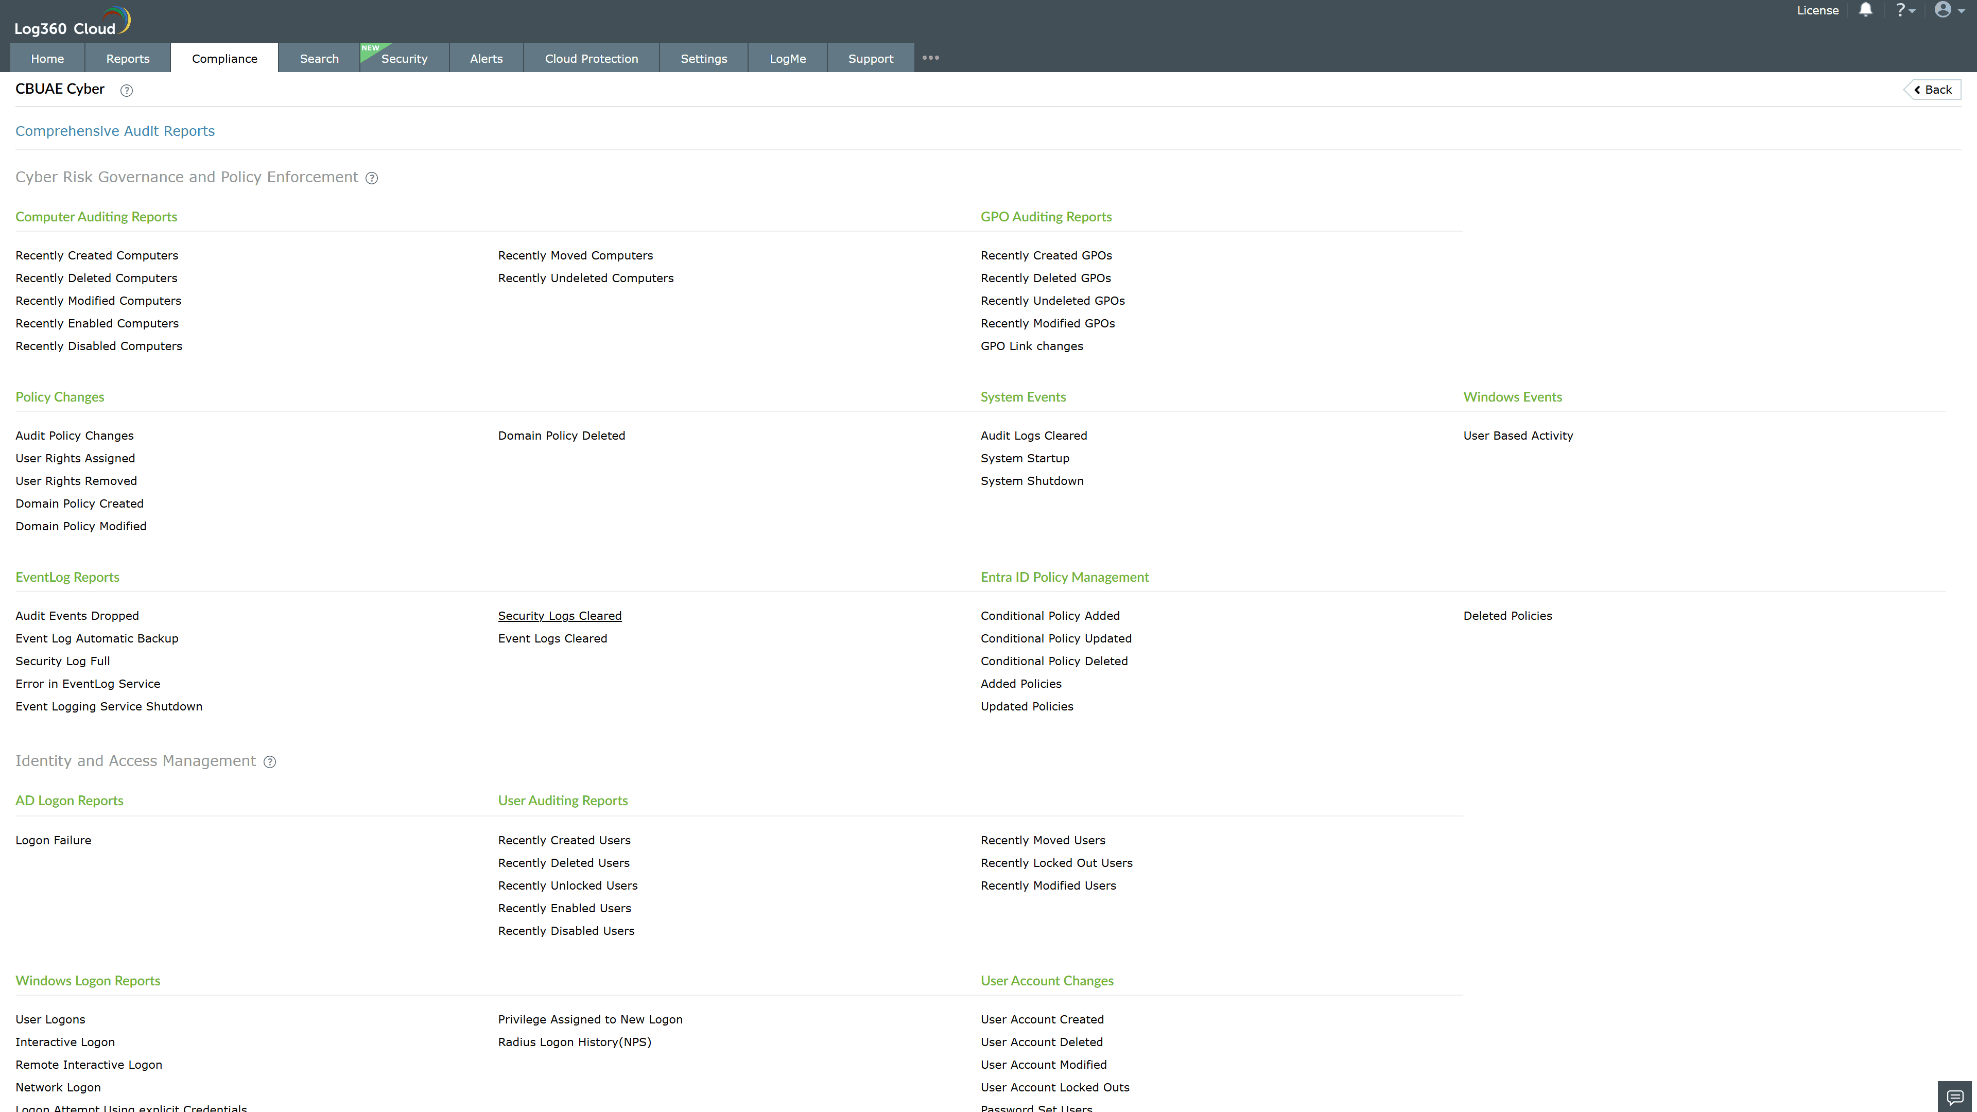
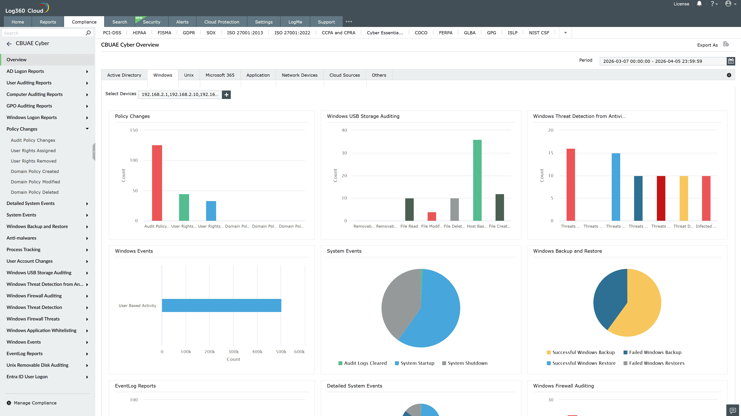
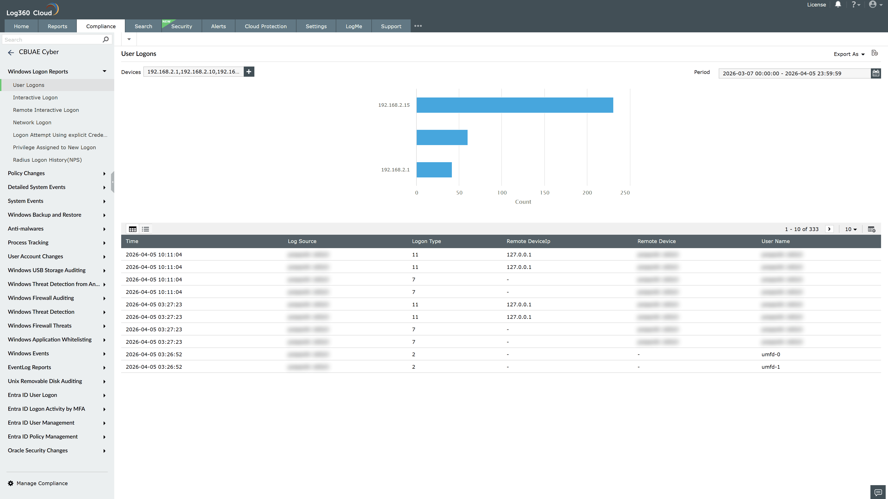
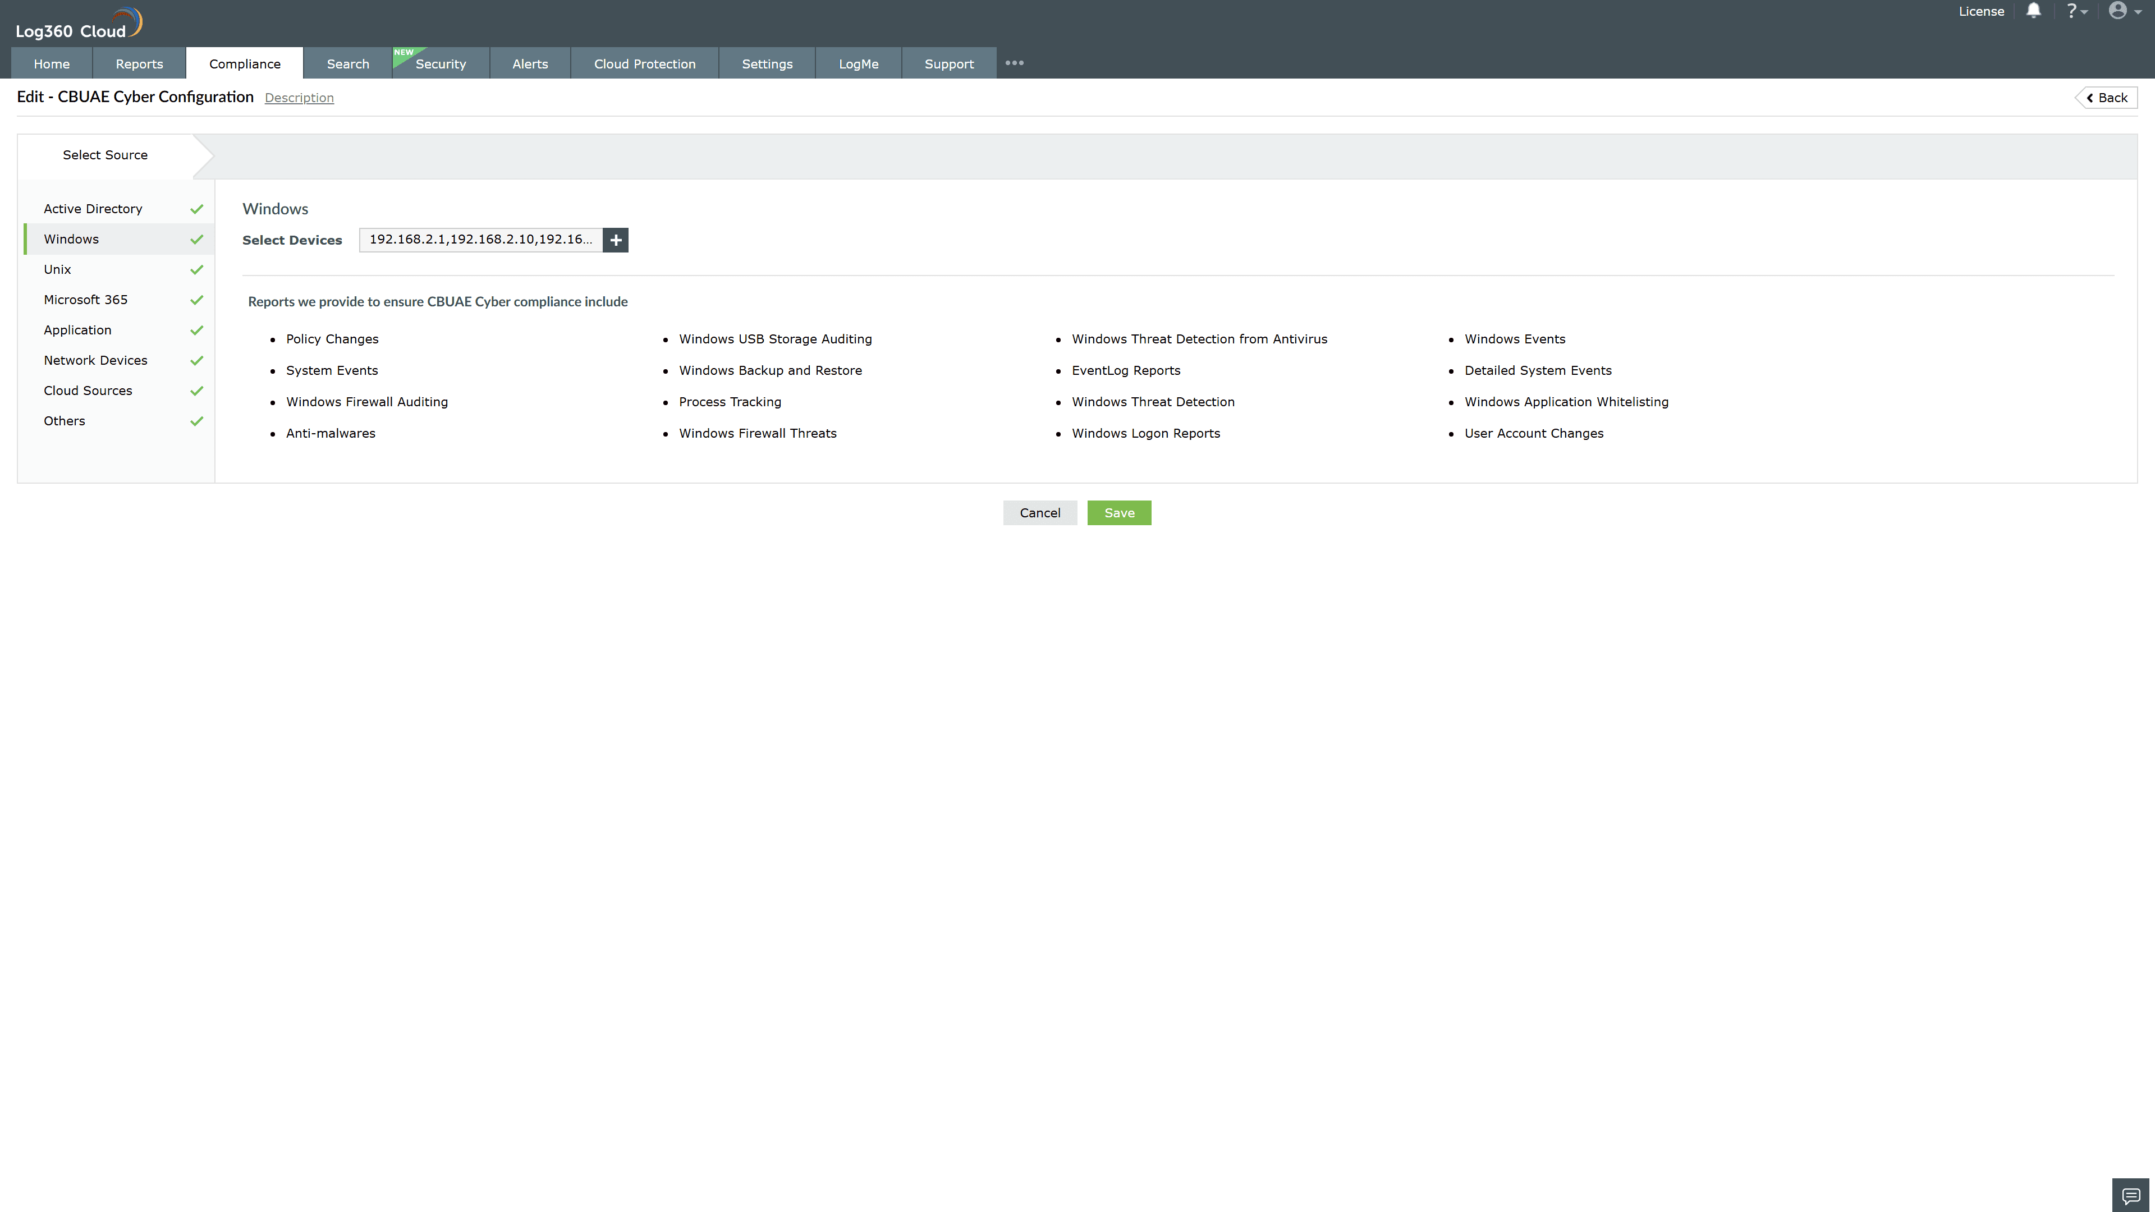
Valid Submission : Yes
Supported Editions : Free, Basic, Standard, Professional, MSSP
Help Document : https://www.manageengine.com/log-management/help/integrations/compliance-extensions.html
Help Video : Not provided
Tags : Log360, Compliance, Privacy monitoring, Data privacy, Regulatory compliance
Supported DCs : US, IN, JP, CA, AU, UK and EU
Privacy Policy:
Terms of Service:
Release Notes:
Predefined reports for the CBUAE Cyber.

